Optimized Prompt Gallery
For mobile native apps

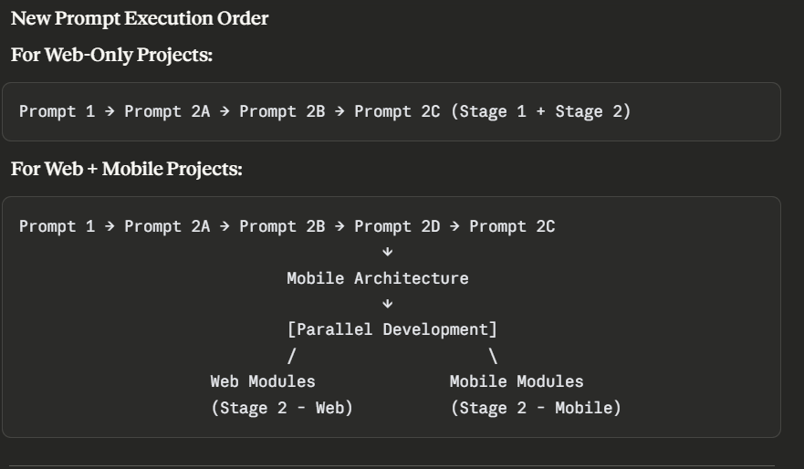
PROMPT 1: Document Analysis (Use Claude Sonnet 4)
You are a senior product analyst specializing in MSME digital solutions.
Analyze the attached Pre-Development Framework and extract ONLY what is explicitly stated or clearly implied.
Output a clear, structured analysis covering:

1. CORE BUSINESS NEED
- Primary problem being solved
- Main app purpose (one sentence)
- Current process/pain points

2. USERS & ROLES
For each user type identified:
- User type name
- Main responsibilities
- Required permissions
- Pain points they face

3. KEY WORKFLOWS
List the primary user journeys described:
- Step-by-step flows provided
- Approval points mentioned
- Automation triggers specified

4. FEATURES
Clearly separate:
- Must-have (MVP): Features without which app is useless
- Phase 2: Mentioned as "nice to have" or "future"
- Implied: Features necessary for workflows but not explicitly listed

5. DATA & INTEGRATIONS
- What data needs to be stored
- External integrations required (WhatsApp, payment, SMS, etc.)
- Reporting requirements

6. TECHNICAL CONSTRAINTS
- Device preferences (mobile/desktop)
- Expected user load
- Budget range mentioned
- Timeline expectations

7. AUTOMATIONS & NOTIFICATIONS
- What should happen automatically
- Who gets notified about what
- Approval workflows required

8. GAPS & ASSUMPTIONS
List anything that is:
- Unclear or ambiguous
- Mentioned but not detailed
- Critical but missing
FORMAT: Write in clear prose with headers. Use bullet points only for lists. Be concise but complete.
CRITICAL: Do NOT invent features. If something is unclear, flag it under "Gaps & Assumptions."

PROMPT 2A: Product Logic & Development Plan (Use Claude Sonnet 4)
Based on your analysis above, create a comprehensive product specification.

TASK 1: Define Core Function
State the single most valuable function this app provides and why it matters most to the business.

TASK 2: User Roles & Permissions (RBAC)
Create a clear access control matrix:
Format:
Role: [Role Name]
Can do:
- [Permission 1]
- [Permission 2]
Cannot do:
- [Restriction 1]
Primary tasks:
- [Main workflow 1]
- [Main workflow 2]

TASK 3: Data Architecture
Define what data entities are needed:
Format:
Entity: [Name]
Fields: [list key fields]
Relationships: [connects to which other entities]
Access rules: [who can read/write/delete]

TASK 4: Primary Workflows
For each critical user journey, document:
- Trigger: What starts this workflow
- Steps: User actions in sequence
- Decision points: Where approvals or conditions apply
- Automations: What happens automatically
- End state: What success looks like

TASK 5: Business Rules
List all:
- Validation rules (e.g., phone must be 10 digits)
- Business logic (e.g., stock reduces when order placed)
- Approval chains (e.g., refund > ₹500 needs manager approval)
- Calculation formulas (e.g., total = price × quantity + tax)

TASK 6: Success Metrics
Define how to measure:
- User success: Task completion faster, fewer errors
- Business impact: More capacity, better tracking
- Operational efficiency: Reduced manual work
OUTPUT: Structured markdown document or artifact (default that claude uses) . Be precise. Reference specific answers from the framework.

PROMPT 2B: Tech Stack & Free-Tier Architecture (Use Claude Sonnet 4)

CONSTRAINTS
- ✅ free-tier or open-source solutions, open for paid tools according to requirements and use case
- ✅ Must support the user load mentioned in framework
- ✅ Must work on device types mentioned (mobile/desktop)
- ✅ Must support required integrations
- ❌ NO over-engineering for MSME scale

YOUR TASK
Analyze the application requirements from Prompt 1 and Prompt 2A, then recommend a tech stack by reasoning through the following dimensions. Do NOT default to any specific technology — choose based on actual needs.

STEP 1: UNDERSTAND THE CORE WORKLOAD
Before recommending any technology, answer these questions based on the framework and product logic:
What is this application's PRIMARY value proposition?
- Is it primarily a UI/interface (users interact with screens/forms)?
- Is it primarily data processing (calculations, transformations, reports)?
- Is it primarily coordination (connecting systems, routing requests)?
- Is it primarily real-time communication (chat, live updates, presence)?
Who uses it and how?
- Public internet users (need SEO, fast page loads, mobile responsiveness)?
- Internal staff only (productivity over polish, desktop-first)?
- Mobile app consuming an API (no web UI needed)?
- Mix of both?
What are the critical operations? List the top 3-5 operations by frequency or business criticality. For each operation, identify:
- Is it CRUD (create/read/update/delete data)?
- Is it computation (calculations, aggregations, transformations)?
- Is it coordination (triggering other systems, sending notifications)?
- Is it presentation (displaying complex UI, visualizations)?
What are the data characteristics?
- Structured relational data (users, orders, products → clear foreign keys)?
- Semi-structured flexible data (varying schemas, nested objects)?
- Heavy read vs heavy write?
- Real-time updates required or eventual consistency acceptable?
- File uploads/downloads involved?
What are the scale requirements?
- How many users (total and concurrent)?
- Requests per day/hour?
- Data volume (MB, GB)?
- Geographic distribution (single region or global)?

STEP 2: EVALUATE TECHNOLOGY FITNESS
For the workload you've identified, evaluate technology options across these dimensions:

A. Language & Runtime Choice
Consider:
- Developer ergonomics: What makes the specific operations EASIER to write and maintain?
  - Example: Heavy CSV/Excel manipulation → Python (pandas) is vastly superior to JavaScript
  - Example: Complex async coordination → Node.js or Python async/await are both fine
  - Example: Simple CRUD → Django (batteries included) vs Next.js (more flexible) vs Rails (convention over config)
- Ecosystem strength: Which language has the best libraries for the PRIMARY operations?
  - Data science/ML → Python (pandas, numpy, scikit-learn, tensorflow)
  - Real-time → Node.js (socket.io, mature WebSocket libs) or Elixir (Phoenix Channels)
  - CRUD-heavy → Python (Django ORM), Ruby (ActiveRecord), JavaScript (Prisma)
  - Image/video processing → Python (Pillow, OpenCV, FFmpeg bindings)
- Team capability: What does the team (if known from framework) already know?
  - If team is Python-only → strongly prefer Python unless workload REQUIRES otherwise
  - If team is JavaScript-only → strongly prefer JavaScript unless workload REQUIRES otherwise
  - If no team info → choose based on workload fit, document why
Output your reasoning:
Based on [primary operations], I recommend [language/runtime] because:
1. [Specific reason tied to workload]
2. [Ecosystem advantage for this use case]
3. [Team fit or learning curve consideration]

Alternative considered: [other language] — not chosen because [specific reason]

B. Frontend Approach
First, determine if a frontend is even needed:
- API-only backend (mobile app, third-party integrations) → No frontend, skip to backend
- Minimal admin interface → Consider using a built-in admin panel (Django Admin, Rails Admin, etc.)
- Full web application → Continue evaluation
For full web applications, evaluate:
Rendering strategy:
- SEO critical (public-facing content) → Server-side rendering (SSR) mandatory
  - Options: Next.js (React), Nuxt (Vue), SvelteKit, Remix
- SEO irrelevant (internal tool, behind login) → Client-side or server-rendered both fine
  - Options: SPA (React, Vue, Svelte) OR server templates (Django, Rails, Laravel, HTMX)
Complexity vs simplicity:
- Complex interactive UI (drag-drop, real-time collaboration, heavy client state) → Component framework
  - Options: React, Vue, Svelte, Solid
- Simple forms and tables (CRUD operations) → Server-rendered may be simpler
  - Options: Django templates + HTMX, Rails views + Hotwire, Laravel Blade + Livewire
Team capability:
- If backend is Python/Ruby/PHP and team doesn't know JavaScript → Server-rendered is faster
- If team knows modern JavaScript → Component framework is fine
- If no team info → Choose based on UI complexity, not popularity
Output your reasoning:
Frontend: [Choice]
Why: [Specific reasoning based on SEO needs, UI complexity, team capability]
Rendering: [SSR / CSR / Server templates + enhancement]

Alternative considered: [other approach] — not chosen because [specific tradeoff]

C. Backend Architecture
Evaluate backend needs independently:
If the frontend choice was server-rendered (Django/Rails/Laravel):
- The backend is already decided (Django backend, Rails backend, etc.)
- Move to database selection
If the frontend is separate (React SPA, Next.js, mobile app):
Consider backend framework based on:
- Primary backend operations (from Step 1):
  - Heavy data processing → FastAPI (Python), Go (performance), Elixir (concurrency)
  - Standard CRUD + auth → Django (batteries included), Rails, Adonis (Node.js)
  - Real-time subscriptions → Node.js (socket.io), Elixir/Phoenix, Supabase
  - API-first with auto-docs → FastAPI (OpenAPI auto-gen), NestJS (TypeScript)
- Integration with frontend:
  - Next.js frontend → Next.js API routes OR separate backend (FastAPI/Django/Express)
  - React/Vue SPA → Any backend with REST/GraphQL
  - Mobile app → FastAPI (fast, typed) or Express (simple, flexible)
- Free-tier hosting availability:
  - Python → Render, Railway, Fly.io (all free tier)
  - Node.js → Vercel, Render, Railway, Fly.io (all free tier)
  - Go/Rust → Fly.io, Railway (free tier)
  - Ruby → Render, Fly.io (free tier)
Output your reasoning:
Backend: [Choice]
Why: [Specific reasoning based on operations, language fit, hosting]
Architecture: [Monolith / Microservices / Serverless / BaaS]
Alternative considered: [other framework] — not chosen because [specific tradeoff]

D. Database Selection
First, determine data model fit:
Relational (SQL) if:
- Clear entity relationships (users have orders, orders have line items)
- ACID transactions required (financial, inventory)
- Complex queries with JOINs
- Mature schema that won't change dramatically → Options: PostgreSQL (Supabase 500MB, Neon 3GB, Railway trial), MySQL (PlanetScale free tier sunset, use Postgres instead)
Document (NoSQL) if:
- Flexible/evolving schema
- Nested data structures (user preferences as JSON)
- Key-value or document lookups dominate over JOINs
- Mobile app with offline sync → Options: Firebase Firestore (1GB free), MongoDB Atlas (512MB free)
SQLite if:
- Single-user or very low traffic (<10 concurrent users)
- Simple schema
- Deploying to long-running server (not serverless) → Options: Turso (libSQL, 500MB free), local SQLite file
Then evaluate specific features needed:
- Real-time subscriptions → Supabase (Postgres + realtime) or Firebase (Firestore + realtime)
- Row-level security → Supabase (built-in RLS)
- Full-text search → PostgreSQL (built-in), Firestore (limited)
- Geospatial queries → PostgreSQL (PostGIS), MongoDB (geospatial indexes)
Finally, check hosting integration:
- Using Render for backend → Render Postgres (included in free tier)
- Using Supabase for auth → Supabase Postgres (integrated)
- Using Firebase for auth → Firebase Firestore (integrated)
- Standalone → Neon (3GB free, better than Supabase for pure database)
Output your reasoning:
Database: [Choice]
Why: [Data model fit, feature requirements, hosting integration]
Free tier: [Specific limits and whether they're sufficient]

Alternative considered: [other database] — not chosen because [specific reason]

E. Authentication Strategy
Evaluate authentication needs:
Use Backend-as-a-Service (BaaS) auth if:
- Standard email/password + social login is sufficient
- Don't want to manage password hashing, session storage, email verification
- Need phone OTP or magic links → Options: Supabase Auth (unlimited users), Firebase Auth (unlimited users)
Use framework built-in auth if:
- Using Django/Rails/Laravel and auth is straightforward (email/password)
- Need tight integration with application logic
- Want full control over auth flow → Django auth, Rails Devise, Laravel Fortify
Use custom JWT auth if:
- API-only backend
- Using FastAPI, Express, or Go
- Need stateless authentication → fastapi-users (Python), Passport.js (Node), golang-jwt (Go)
Use third-party auth if:
- Complex SSO requirements (Google Workspace, Azure AD, Okta)
- Social login with many providers → Auth0 (7,500 users free), NextAuth.js (open source)
Output your reasoning:
Authentication: [Choice]
Why: [Integration fit, feature requirements, complexity]
Login methods: [Email/password, phone OTP, social, magic link, etc.]

Alternative considered: [other approach] — not chosen because [specific reason]

F. File Storage (if applicable)
Determine file storage needs from framework:
- If no file uploads mentioned → Skip this section
- If file uploads are needed → Continue
Evaluate by file type:
Images (photos, avatars, product images): → Cloudinary (25GB storage, 25GB bandwidth/month) — auto-optimization, transformations, CDN → Alternative: Supabase Storage (1GB) if already using Supabase
Documents (PDFs, spreadsheets, text files): → Supabase Storage (1GB) or Firebase Storage (5GB) → Alternative: Cloudinary if public documents
Large files (videos, datasets): → Backblaze B2 (10GB free, S3-compatible) → Alternative: Skip free tier, warn client about costs
Output your reasoning:
File Storage: [Choice]
Why: [File type fit, storage limits, integration with stack]
Free tier: [Specific limits and sufficiency]
Alternative considered: [other service] — not chosen because [specific reason]

G. Hosting Strategy
Match hosting to the stack you've chosen:
For Python (Django/FastAPI/Flask):
- Render (750 hours/month free, includes Postgres, auto-sleep after 15min)
- Railway ($5 trial credit, ~500 hours, includes Postgres)
- Fly.io (3 VMs × 256MB free, includes Postgres)
- PythonAnywhere (free tier for simple Flask apps, very limited)
For Node.js (Express/Nest/Adonis):
- Render (750 hours/month free, same as Python)
- Railway ($5 trial credit)
- Vercel (if Next.js or serverless functions)
- Fly.io (3 VMs free)
For Next.js full-stack:
- Vercel (unlimited bandwidth, 100GB/month, best integration)
- Netlify (100GB bandwidth/month)
- Cloudflare Pages (unlimited bandwidth, serverless functions)
For Static Sites (React SPA, Vue SPA):
- Cloudflare Pages (unlimited bandwidth, best performance)
- Netlify (100GB bandwidth/month)
- Vercel (100GB bandwidth/month)
For API + separate frontend:
- Backend → Render/Railway/Fly.io
- Frontend → Cloudflare Pages/Netlify
Output your reasoning:
Hosting:
- Frontend: [Service] — [why it's the best fit]
- Backend: [Service] — [why it's the best fit]
Free tier capacity: [Expected usage vs limits, when scale triggers paid tier]
Alternative considered: [other host] — not chosen because [specific reason]

H. Integrations & External Services
For each integration mentioned in the framework (WhatsApp, SMS, email, payment, etc.):
Evaluate:
- Official SDKs available for chosen backend language?
- Free tier sufficient for expected volume?
- Setup complexity (KYC, approval time, testing)?
Common integrations:
- WhatsApp → Meta Business Cloud API (1000 conversations/month free) — works with any backend
- SMS (India) → MSG91, Fast2SMS — works with any backend, requires DLT registration
- SMS (Global) → Twilio (trial credits) — works with any backend
- Email → Resend (3000/month free, Python + JS SDKs), SendGrid (100/day free)
- Payments (India) → Razorpay (Python + JS SDKs, KYC required 2-3 days)
- Payments (Global) → Stripe (Python + JS SDKs, KYC required)
Output for each integration:
Integration: [Service name]
API: [Service provider]
SDK: [Python / JavaScript / Both / REST only]
Free tier: [Limits and sufficiency]
Setup time: [Immediate / 1-2 days / 3-7 days for approvals]

STEP 3: OUTPUT YOUR RECOMMENDATION
Provide the complete stack with clear justification:

Technology Stack
Frontend:
- Framework: [Specific choice]
- Why: [Reasoning based on SEO, UI complexity, team fit]
- UI Library: [Tailwind, Bootstrap, custom CSS, or none]
- State Management: [If applicable: Context, Zustand, Tanstack Query, etc.]
- Hosting: [Service name + free tier limits]
Backend:
- Framework: [Specific choice]
- Why: [Reasoning based on operations, language fit, integrations]
- Language: [Python / JavaScript / Ruby / Go / etc.]
- Hosting: [Service name + free tier limits]
Database:
- Type: [PostgreSQL / Firestore / SQLite / etc.]
- Provider: [Supabase / Neon / Firebase / Railway / etc.]
- Why: [Data model fit, features needed, integration]
- Free tier: [Storage limit + sufficiency]
Authentication:
- Method: [BaaS / Framework built-in / Custom JWT / Third-party]
- Provider: [Supabase Auth / Firebase Auth / Django auth / etc.]
- Login options: [Email, phone, social, magic link]
File Storage (if needed):
- Provider: [Cloudinary / Supabase / Firebase / etc.]
- Why: [File type fit, transformation needs]
- Free tier: [Storage + bandwidth limits]
Integrations:
- [List each: Service → Provider → Free tier limits]

Architecture Diagram
Draw the data flow for YOUR specific recommendation:
[User/Device]
↓
[Frontend - where and what]
↓
[Backend - where and what]
↓
[Database - where and what]
↓
[External Services - list]

Be specific — don't use generic placeholders.

Free Tier Capacity Analysis
Based on framework requirements:
- Expected users: [from framework]
- Expected daily requests: [estimate based on workflows]
- Database size estimate: [based on entities and volumes]
- Storage needs: [based on file upload scenarios]
Capacity check:
✅ Fits within free tier if: [condition]
⚠️ Will need paid tier when: [specific scale threshold]

Breakdown:
- Frontend hosting: [usage vs limit]
- Backend hosting: [hours vs limit, cold start impact]
- Database: [storage vs limit, connection pool vs limit]
- File storage: [volume vs limit]
- Integrations: [usage vs limit for each]

Tradeoffs & Alternatives
Document what you DIDN'T choose and why:
Considered but rejected:
1. [Alternative stack/service] — Reason: [specific tradeoff]
2. [Alternative approach] — Reason: [specific limitation for this use case]
3. [Popular option] — Reason: [why it's not the best fit here]

This helps the client understand the decision wasn't arbitrary.

DESIGN BRIEF
Using the MSME's framework answers (branding preferences, design style, business sector, user type, overall feeling desired), generate a concrete Design Brief.
Output EXACTLY this block — nothing more:
DESIGN_BRIEF_START
THEME: [one word — dark / warm-light / high-contrast / earthy / clinical / industrial / minimal]
PERSONALITY: [two words describing the overall feel e.g. "precise warm" or "bold playful"]

FONTS:
Heading: [specific Google Font name + weight — must NOT be Inter, Roboto, Arial, or system-ui]
Body: [specific Google Font name + weight — must NOT be Inter, Roboto, Arial, or system-ui]
Accent: [display or mono font if it adds value, otherwise "none"]

COLORS (CSS variables — all hex values):
--color-bg: [hex] ← page background
--color-surface: [hex] ← cards, panels
--color-border: [hex] ← dividers, outlines
--color-text: [hex] ← primary text
--color-text-muted: [hex] ← labels, secondary text
--color-primary: [hex] ← dominant brand color
--color-accent: [hex] ← sharp contrast color for CTAs and highlights
--color-success: [hex]
--color-warning: [hex]
--color-danger: [hex]

BACKGROUND: [one sentence describing technique — gradient / geometric pattern / noise texture / grid]
MOTION: [one sentence — page-load stagger timing + key interaction micro-animations]
LAYOUT: [one sentence — density, spacing, card vs table vs list philosophy]
AVOID: [3 highly specific clichés to skip for THIS business type]
REFERENCE: [name a real app, IDE theme, or cultural aesthetic that captures the target vibe]
DESIGN_BRIEF_END

Grounding rules (follow strictly):
- A logistics tool ≠ a bakery app ≠ a clinic ≠ a retail store — context drives every choice
- Dark themes → industrial, technical, ops-heavy tools / Light themes → hospitality, retail, health
- Use ONE dominant color + ONE sharp accent — never distribute palette evenly across UI
- If MSME has existing brand colors → incorporate them, never override
- If MSME has no preference → make a strong, unexpected creative call for their industry
- Forbidden at all times: Inter, Roboto, Arial, system-ui, purple-on-white gradients, generic SaaS blue #3B82F6, Space Grotesk
- Vary between light and dark — do not default to dark just because it looks "designed"
Copy the DESIGN_BRIEF_START...END block and save it separately. It will be injected into every UI module prompt in Stage 2.

OUTPUT REQUIREMENTS:
- Complete tech stack with justification for each choice
- Architecture diagram specific to your recommendation
- Free tier capacity analysis
- Tradeoffs & alternatives section
- Design brief block
Do not output generic recommendations. Every choice must be grounded in the specific application's workload, scale, and context.

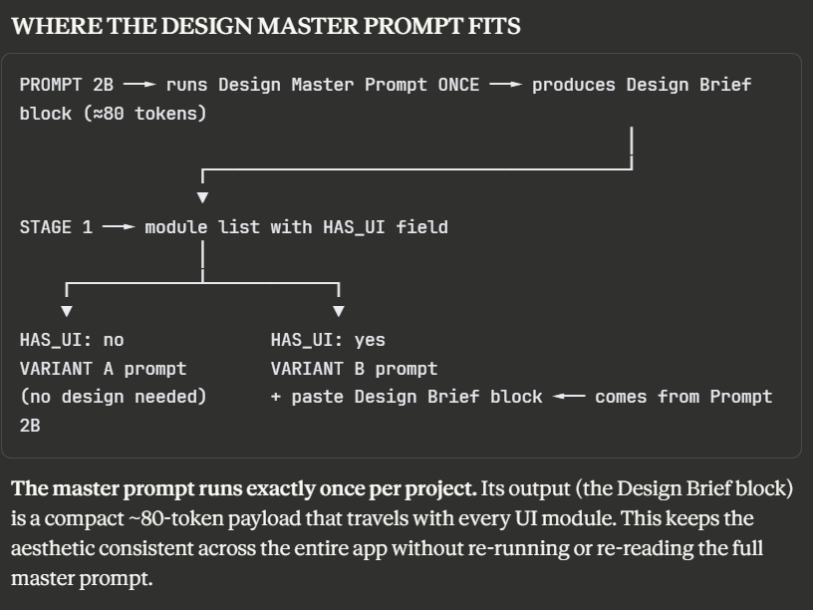
PROMPT 2C: Antigravity Development Prompts (Use Claude Sonnet 4)
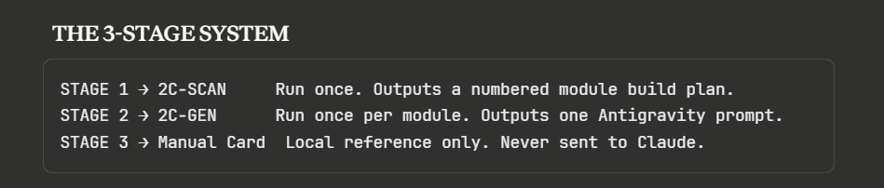

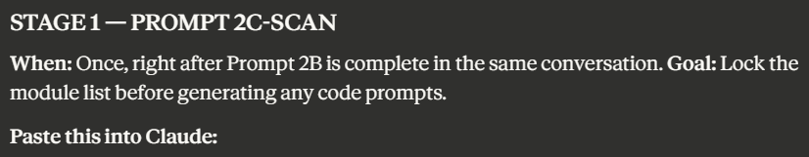Based on the tech stack from Prompt 2B and the product logic from Prompt 2A,
produce a BUILD PLAN as a numbered module list.

STEP 1 — CLASSIFY every feature/task from Prompt 2A into one of two tiers:

COMPLEX (must be its own isolated module — never merge):
- Has APPROVALS or multi-step approval chain
- Has AUTOMATIONS with external triggers (webhooks, cron, event chains)
- Is a third-party integration with its own error handling (payment, WhatsApp, SMS, OAuth)
- Is the auth system or database schema (touched by everything else)
- Has 3 or more distinct business rules or calculations
- Is a real-time or live-sync feature

SIMPLE (merge candidate):
- Pure CRUD with no business logic beyond basic validation
- Same entity, same data owner, no external calls
- UI-only: shared layout shell, nav, sidebar, error/empty states
- Config or lookup tables (categories, status types, tags)
- Read-only report or export with no write operations
- Profile/account settings with no workflow dependencies

STEP 2 — MERGE simple tasks using these rules:
- Merge up to 3 simple tasks into one module ONLY if they share the same entity OR
the same screen area OR have no dependencies on each other
- Never merge tasks from different complexity tiers
- Never merge tasks that have different INTEGRATIONS
- Never merge a task that has APPROVALS=yes with anything else
- Never merge if the combined module would produce more than 4 UI components
or more than 5 DB operations — split instead
- Name the merged module after the dominant concern, list sub-tasks inside CONTAINS

STEP 3 — OUTPUT the final module list using EXACTLY this structure per module:

MODULE [N]: [Name]
COMPLEXITY: [complex | simple | merged]
CONTAINS: [sub-task 1, sub-task 2 — only for merged; "n/a" for others]
TECH: [specific service/library for this module only]
INPUT: [data/state that enters this module]
OUTPUT: [what this module produces]
DEPENDS ON: [module numbers or "none"]
INTEGRATIONS: [external APIs needed, or "none"]
APPROVALS: [yes — rule | no]
AUTOMATIONS: [yes — trigger | no]
HAS_UI: [yes | no]
MANUAL SETUP: [one-line summary of manual steps needed, or "none"]

TARGET: 8–15 modules for a standard app. 15–22 for a large multi-role app.
If you exceed 22, re-examine your simple modules and merge further.
Output the list only. No code, no explanations.

PROMPT 2D: Mobile App Architecture (Use Claude Sonnet 4)

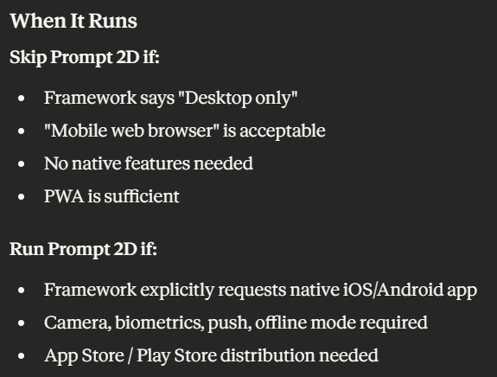

PROMPT 2D: Mobile App Architecture (Use Claude Sonnet 4)
When to run: After Prompt 2B AND Prompt 2C (web backend) are complete, IF the framework indicates mobile app is needed.
Skip this prompt if:
- Application is web-only (desktop/mobile web browser)
- PWA (Progressive Web App) is sufficient for the use case
Run this prompt if:
- Framework explicitly requests native mobile app (iOS/Android)
- Native features required: camera, biometrics, push notifications, offline-first
- App Store / Play Store distribution needed

YOUR TASK
Design a native mobile app architecture that consumes the backend API designed in Prompt 2C.

STEP 1: MOBILE REQUIREMENTS ANALYSIS
Based on the framework and Prompt 2C backend, answer:

A. Platform Scope
Target platforms (check framework Q16 "device preferences"):
- [ ] iOS only
- [ ] Android only
- [ ] Both iOS and Android (most common for MSMEs)

Reasoning: [Based on target user base from framework]

B. Native Feature Requirements
Review the framework and Prompt 2A workflows. Identify which native features are needed:
Native features required:
- [ ] Camera (for photo upload, QR scanning, document scanning)
- [ ] Push notifications (order updates, alerts, reminders)
- [ ] Biometric auth (fingerprint, Face ID for security)
- [ ] Offline mode (work without internet, sync later)
- [ ] Location services (GPS tracking, geofencing, maps)
- [ ] Contacts access (import phone numbers)
- [ ] Calendar integration (schedule bookings, reminders)
- [ ] File system access (download/save documents locally)
- [ ] Phone calls / SMS (click-to-call, send SMS)
- [ ] Bluetooth (for IoT device connections)
- [ ] Background tasks (location tracking, data sync)

For each checked feature, explain why it's needed based on the workflows.

C. Offline Strategy
Determine offline requirements:
Offline needs:
- [ ] No offline (always requires internet)
- [ ] Read-only offline (view cached data, no edits)
- [ ] Full offline (create/edit data, sync when online)

If offline mode required:
- Which entities need offline access? [list from Prompt 2A data model]
- Conflict resolution strategy: [last-write-wins / manual resolution / server-authoritative]
- Sync frequency: [on app open / real-time / manual / periodic]

STEP 2: TECHNOLOGY STACK RECOMMENDATION

A. Framework Choice
Evaluate based on requirements:
React Native (Expo) if:
- Team already knows React/JavaScript (from Prompt 2B backend choice)
- Standard mobile UI (forms, lists, maps)
- Need fast development (Expo managed workflow)
- Cross-platform is priority
- Budget is tight (single codebase)
React Native (Bare) if:
- Need custom native modules not available in Expo
- Performance-critical animations
- Deep integration with native APIs
- Team can handle native code (Xcode, Android Studio)
Flutter if:
- Team knows Dart or willing to learn
- Need pixel-perfect custom UI
- Performance is critical (60fps animations)
- Web + mobile from same codebase (Flutter Web)
- No reliance on JavaScript ecosystem
Native (Swift + Kotlin) if:
- Maximum performance required
- Platform-specific UX critical (iOS feels iOS, Android feels Android)
- Complex native features (AR, advanced Bluetooth, etc.)
- Budget allows separate iOS and Android teams
Output your reasoning:
Recommended framework: [React Native Expo / React Native Bare / Flutter / Native]

Why:
1. [Team capability alignment with backend stack]
2. [Feature requirements that this framework handles best]
3. [Development speed vs performance tradeoff]
4. [Budget/timeline constraints from framework]

Alternative considered: [other framework]
Not chosen because: [specific limitation for this use case]

If React Native: Use Expo managed workflow
If Flutter: Use Flutter 3.x with Material 3 / Cupertino widgets
If Native: Recommend starting with one platform (iOS or Android) for MVP

B. State Management
Based on app complexity from Prompt 2A:
Simple apps (< 10 screens, minimal shared state):
- React Native → React Context + useState
- Flutter → Provider + ChangeNotifier
Medium apps (10-30 screens, moderate shared state):
- React Native → Zustand or Tanstack Query
- Flutter → Riverpod
Complex apps (30+ screens, heavy state, offline sync):
- React Native → Redux Toolkit + RTK Query + redux-persist
- Flutter → Riverpod + Hive/Isar for local storage
Output:
State management: [Choice]
Why: [App complexity, offline needs, team familiarity]
Local persistence (if needed): [AsyncStorage / SecureStore / Hive / Isar]

C. Navigation Strategy
Based on app structure:
Tab-based navigation (common for consumer apps):
- React Native → React Navigation (Bottom Tabs)
- Flutter → flutter_bottom_navigation_bar
Stack-based navigation (common for workflow apps):
- React Native → React Navigation (Stack Navigator)
- Flutter → Navigator 2.0
Drawer navigation (for admin/internal tools):
- React Native → React Navigation (Drawer)
- Flutter → Drawer widget
Output:
Navigation pattern: [Tabs / Stack / Drawer / Hybrid]
Why: [Based on user workflows and app structure]
Library: [React Navigation / Flutter Navigator 2.0]

D. API Integration
Connect to backend from Prompt 2C:
Backend API: [From Prompt 2C: FastAPI / Django / Express / etc.]
Base URL: [Production URL from Prompt 2C hosting]

HTTP Client:
- React Native → Axios or fetch + Tanstack Query
- Flutter → Dio or http + Riverpod AsyncNotifier

Authentication flow:
- Token storage: [SecureStore / Keychain / EncryptedSharedPreferences]
- Token refresh: [Automatic via interceptor]
- Logout: [Clear tokens + navigate to login]

If offline sync:
- Queue failed requests: [Use redux-persist / Hive queue]
- Retry strategy: [Exponential backoff, max 3 retries]

E. UI Component Library
Reduce development time with pre-built components:
React Native:
- React Native Paper (Material Design) — free, well-maintained
- NativeBase v3 — free, customizable
- React Native Elements — free, minimal
- Tamagui — high-performance, paid pro features
Flutter:
- Material 3 (built-in) — free, follows Android design
- Cupertino (built-in) — free, follows iOS design
- FlutterFlow UI Kit — drag-drop, paid
- GetWidget — free, large component library
Output:
UI Library: [Choice]
Why: [Design language fit, customization needs, free tier availability]
Design system: [Material / iOS / Custom from Design Brief]

F. Push Notifications
If push notifications are required (from Step 1B):
Service options:
- Firebase Cloud Messaging (FCM) — free, unlimited, both platforms
- OneSignal — free tier: 10,000 subscribers, easier than FCM
- Expo Notifications (if using Expo) — wraps FCM, simpler setup
Implementation:
Push service: [FCM / OneSignal / Expo Notifications]
Why: [Integration ease, free tier limits, team capability]

Notification types needed:
- [List from Prompt 2A automations: order updates, payment confirmations, etc.]

Delivery triggers:
- [Server-side from backend: send via FCM API when X happens]

Manual setup:
- Get FCM server key → add to backend env vars
- Configure iOS push certificates (Apple Developer account required)
- Test on physical device (push doesn't work in simulator)

G. Analytics & Crash Reporting
Track usage and errors:
Free options:
- Firebase Analytics + Crashlytics (free, unlimited)
- Sentry (free tier: 5,000 errors/month)
- PostHog (open source, self-host or cloud free tier)
Output:
Analytics: [Firebase Analytics / PostHog / None for MVP]
Crash reporting: [Firebase Crashlytics / Sentry]
Why: [Privacy, free tier, integration ease]

H. App Store Distribution
iOS (App Store):
- Apple Developer account required: $99/year
- Review time: 1-3 days (can be rejected, requires fixes)
- TestFlight for beta testing (free, no review)
Android (Play Store):
- Google Play Developer account: $25 one-time
- Review time: hours to 1 day (usually faster than iOS)
- Internal testing track for beta (free, no review)
Alternative distribution (for internal apps):
- iOS → Ad-hoc distribution (max 100 devices, requires UDID)
- Android → APK direct download (enable "unknown sources")
Output:
Distribution strategy:
- iOS: [App Store / TestFlight / Ad-hoc]
- Android: [Play Store / APK direct / Internal testing]

Account setup:
- [ ] Apple Developer ($99/year) — required for iOS App Store
- [ ] Google Play Developer ($25 one-time) — required for Android Play Store

Estimated review timeline: [1-3 days iOS, few hours Android]

STEP 3: MOBILE ARCHITECTURE

A. Architecture Diagram
Draw mobile-specific architecture:
Mobile App (iOS/Android)
↓
[Framework: React Native/Flutter]
↓
State Management: [Zustand/Riverpod/Redux]
↓
API Layer: [Axios/Dio + Tanstack Query]
↓
Backend API (from Prompt 2C)
[FastAPI/Django/Express at backend-url.com]
↓
Database (from Prompt 2C)
[Supabase Postgres / Firebase / Neon]

Native features used:
- Push: Firebase Cloud Messaging
- Auth: [Supabase Auth / Firebase Auth / Custom JWT]
- Storage: [Device local: AsyncStorage/Hive]
- Camera: [expo-camera / image_picker]

B. Folder Structure
Provide recommended project structure:
React Native (Expo):
/src
/screens # One file per screen
/components # Reusable UI components
/hooks # Custom hooks (useAuth, useAPI)
/services # API calls (auth.service.js, orders.service.js)
/store # State management (Zustand/Redux)
/utils # Helpers (formatDate, validation)
/navigation # Navigation config
/assets # Images, fonts
/config # API URLs, constants
App.js # Root component
app.json # Expo config

Flutter:
/lib
/screens # One file per screen
/widgets # Reusable widgets
/models # Data models
/services # API calls
/providers # Riverpod providers
/utils # Helpers
/routes # Navigation
/assets # Images, fonts
/config # Constants
main.dart # Entry point
pubspec.yaml # Dependencies

STEP 4: MOBILE-SPECIFIC MODULE PLAN
Generate a module list specifically for the mobile app, separate from the web modules in Prompt 2C.
Format (same as Prompt 2C Stage 1 SCAN):
MOBILE MODULE [N]: [Name]
COMPLEXITY: [complex | simple | merged]
CONTAINS: [sub-task 1, sub-task 2 — if merged; "n/a" otherwise]
TECH: [React Native Expo / Flutter]
SCREENS: [list screen names this module produces]
NATIVE FEATURES: [camera / push / biometric / location / none]
DEPENDS ON: [module numbers or "none"]
BACKEND API: [which backend endpoints from Prompt 2C this module calls]
OFFLINE: [yes — which data / no]

Example modules:
MOBILE MODULE 1: Authentication Flow
COMPLEXITY: complex
CONTAINS: n/a
TECH: React Native Expo
SCREENS: Login, Signup, OTP Verification, Password Reset
NATIVE FEATURES: biometric (optional fingerprint login)
DEPENDS ON: none
BACKEND API: POST /auth/login, POST /auth/signup, POST /auth/verify-otp
OFFLINE: no

MOBILE MODULE 2: Order Placement
COMPLEXITY: complex
CONTAINS: n/a
TECH: React Native Expo
SCREENS: Product List, Product Detail, Cart, Checkout, Order Confirmation
NATIVE FEATURES: camera (product photo upload), push (order confirmation)
DEPENDS ON: Module 1 (auth)
BACKEND API: GET /products, POST /orders, GET /orders/:id
OFFLINE: yes — cache product list, queue order submission

MOBILE MODULE 3: Order Tracking
COMPLEXITY: simple
CONTAINS: n/a
TECH: React Native Expo
SCREENS: Order List, Order Detail with status timeline
NATIVE FEATURES: push (status updates)
DEPENDS ON: Module 1 (auth)
BACKEND API: GET /orders, GET /orders/:id
OFFLINE: yes — cache recent orders

MOBILE MODULE 4: Profile & Settings
COMPLEXITY: simple
CONTAINS: Profile edit, Change password, Notification settings, Logout
TECH: React Native Expo
SCREENS: Profile, Settings
NATIVE FEATURES: camera (profile photo), biometric (toggle on/off)
DEPENDS ON: Module 1 (auth)
BACKEND API: GET /users/me, PATCH /users/me
OFFLINE: no

Target: 5-12 mobile modules for a standard mobile app.

STEP 5: MOBILE DEVELOPMENT GUIDE

A. Environment Setup Checklist
For React Native (Expo):
□ Install Node.js 18+
□ Install Expo CLI: npm install -g expo-cli
□ Install Expo Go app on physical device (for testing)
□ Create project: npx create-expo-app my-app
□ Install dependencies: npm install axios zustand react-navigation/native
□ Run: npx expo start (scan QR with Expo Go)

For Flutter:
□ Install Flutter SDK 3.x
□ Install Android Studio (for Android emulator)
□ Install Xcode (for iOS simulator, Mac only)
□ Run: flutter doctor (verify setup)
□ Create project: flutter create my_app
□ Install dependencies: flutter pub add dio riverpod
□ Run: flutter run (select device)

B. Backend Integration Steps
1. Get backend API base URL from Prompt 2C deployment
Example: https://myapp-backend.onrender.com

2. Create API config file:
React Native: src/config/api.js
Flutter: lib/config/api_config.dart

3. Set base URL:
const API_BASE_URL = 'https://myapp-backend.onrender.com';

4. Test connectivity:
- Call GET /health or any public endpoint
- Verify CORS is configured on backend (allow mobile origin)

5. Implement auth token flow:
- Store token in SecureStore (RN) or FlutterSecureStorage (Flutter)
- Add token to headers: Authorization: Bearer <token>
- Refresh token if 401 response

6. Map each backend endpoint to a service function:
Example: orders.service.js → getOrders(), createOrder(), etc.

C. Design Integration
Apply the Design Brief from Prompt 2B to the mobile app:
From DESIGN_BRIEF_START...END block:

1. Colors:
- Extract CSS variables → convert to mobile constants
- React Native: const colors = { primary: '#HEX', ... }
- Flutter: const Color primary = Color(0xFFHEXVAL);

2. Fonts:
- Download Google Fonts specified in Design Brief
- Add to assets/fonts/
- Configure in app.json (RN) or pubspec.yaml (Flutter)

3. Spacing/Layout:
- Use LAYOUT guidance from Design Brief
- Create spacing constants: xs: 4, sm: 8, md: 16, lg: 24, xl: 32

4. Motion:
- Apply MOTION timing from Design Brief
- React Native: use Animated or Reanimated
- Flutter: use AnimatedContainer, Hero animations

5. Avoid rules:
- Follow AVOID guidelines from Design Brief
- Don't use forbidden fonts/colors on mobile either

D. Testing Checklist
Device testing:
□ Test on real iOS device (push, biometric, camera)
□ Test on real Android device
□ Test on different screen sizes (small phone, tablet)
□ Test offline mode (airplane mode)
□ Test poor network (slow 3G simulation)

Feature testing:
□ All authentication flows work
□ All API calls succeed
□ Push notifications arrive
□ Native features work (camera, biometric)
□ Offline data syncs correctly
□ Navigation feels smooth
□ Forms validate correctly

Performance:
□ App opens in < 3 seconds
□ No dropped frames in animations
□ Images load efficiently
□ No memory leaks (test with long session)

E. Deployment Preparation
iOS Deployment:
1. Join Apple Developer Program ($99/year)
2. Create App ID in Apple Developer portal
3. Create App Store Connect listing
4. Generate provisioning profiles
5. Build IPA: expo build:ios or flutter build ios
6. Upload via Transporter app or Xcode
7. Submit for review (screenshots, description, privacy policy)
8. Wait 1-3 days for review

Android Deployment:
1. Join Google Play Developer ($25 one-time)
2. Create app listing in Play Console
3. Generate signed APK/AAB: expo build:android or flutter build appbundle
4. Upload AAB to Play Console
5. Complete store listing (screenshots, description)
6. Submit for review (few hours to 1 day)

OUTPUT SUMMARY
Provide:
- Technology Stack:
  - Framework: [React Native Expo / Flutter / etc.]
  - State management: [Zustand / Riverpod / etc.]
  - UI library: [React Native Paper / Material 3 / etc.]
  - Navigation: [React Navigation / Flutter Navigator]
  - Push: [FCM / OneSignal]
  - Analytics: [Firebase Analytics / Sentry]
- Module List:
  - [List all mobile modules in SCAN format]
- Architecture Diagram:
  - [Mobile app → API → Backend → Database flow]
- Development Timeline Estimate:
  - Setup: [X days]
  - Module 1-N development: [X days each]
  - Testing: [X days]
  - App store submission: [X days]
  - Total: [X weeks]
- App Store Costs:
  - iOS: $99/year (Apple Developer)
  - Android: $25 one-time (Google Play Developer)
  - Total first year: $124
- Next Steps:
  - Complete backend development (Prompt 2C modules)
  - Set up mobile development environment
  - Generate mobile modules one-by-one (use Stage 2 process adapted for mobile)
  - Test on physical devices
  - Submit to app stores

